Meeting for Worship in Balby (Doncaster) Quaker Meeting House during the
Covid 19 Pandemic
Short extract from QF & P/A & Q – something about keeping the meeting going or being friends together or being a community
It will be wonderful for some of us to be able to see each other in real life but it will be very different to pre-covid Sunday mornings. We hope that the love in our community will help us minimise the difficulties and find joy in meeting in person again.
This Photo by Unknown Author is licensed under CC BY-NC
These arrangements are based on government regulations and guidance from Friends House. Much of this advice will be common sense but we need to state it.
At first, things will be very simple. There will be one Meeting for Worship at 10.30 on a Sunday.
Covid 19 Safety Co-ordinator
X, as a Trustee, is the Safety Co-ordinator for the Meeting House. There will be several deputies and one of these will be present each Sunday. Their role is to support us all in keeping within the regulations and make sure that we are all as safe as possible. They may ask other Friends to help them with this.

Should you come to the Meeting House?
This Photo by Unknown Author is licensed under CC BY-NC
You must not come to the Meeting House if you have Covid symptoms or anyone in your household has developed symptoms during the last 14 days. Covid symptoms are a new cough, and/or high temperature, and/or loss of, or change in, your normal sense of smell or taste.
Apart from this it is your decision whether to come to the Meeting House. You will need to consider the risk involved; the risk to you or to someone in your household or the risk you pose to others. You are at increased risk from Covid if you are over 70 or have certain medical conditions: see NHS guidance and you may put others at risk if you work in a clinical setting.

What to bring with you and travelling to the Meeting House
Please take your temperature before you leave home.
There will be no drinking water available in the Meeting House (except in emergencies) and no books on the table in the meeting room. So please bring:
- A face covering (strongly recommended)
- Books for your own use: Quaker faith & practice, Advices & queries, Bible - or use mobile phone / tablet
- Water bottle

- Rubbish bag – to take away used tissues etc.
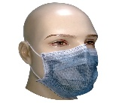
This Photo by Unknown Author is licensed under CC BY-SA
This Photo by Unknown Author is licensed under CC BY-SA-NC
This Photo by Unknown Author is licensed under CC BY-NC
This Photo by Unknown Author is licensed under CC BY-SA
Please try to walk or cycle to the Meeting House if you can. If you drive and offer a lift to someone please check the government guidance. If you have to use public transport remember that you will need a face covering. We ask those using a car to consider leaving enough space between cars to ensure an easy exit is possible.
If possible, use the loo before you leave home to avoid a queue in the Meeting House.

Reserving a place at Meeting for Worship and test and trace
There will only be 16 places at the Meeting for Worship. You will need to reserve your place using the electronic booking system or by phone – see separate information. Some places will be held for people recommended by Overseers, for instance those who have not been able to access online Meeting for Worship. . Because of the “test and trace” system we are required to have contact details for anyone who comes to the Meeting House. These will be recorded and used only for test and trace purposes and deleted 21 days after the meeting for worship.

When you arrive at the Meeting House
Please arrive early. It will take you longer to get to the meeting room. When you arrive, you may need to queue, keeping 2 metres distant from other Friends. Please put on your face covering. Someone will remind you about the guidance and record the time of your arrival. If you arrive without having booked you will be asked to wait outside until we can check numbers.
This Photo by Unknown Author is licensed under CC BY-SA
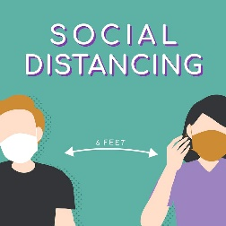
The Meeting House door will be locked at 10.40.

Once inside the Meeting House please sanitise or wash your hands and go straight into the Meeting Room
There will be no leaflets in the social space and the library cupboards will be closed. Take all your belongings into the Meeting Room with you.

In the Meeting Room
The Meeting Room will have been empty for more than 72 hours. The doors will be open and will stay open. The fire exit door will also be open. Chairs will be 2 metres apart. But if you are with a member of your household please sit together to create more space for others. We will need to fill the room from the back.

During Meeting for Worship
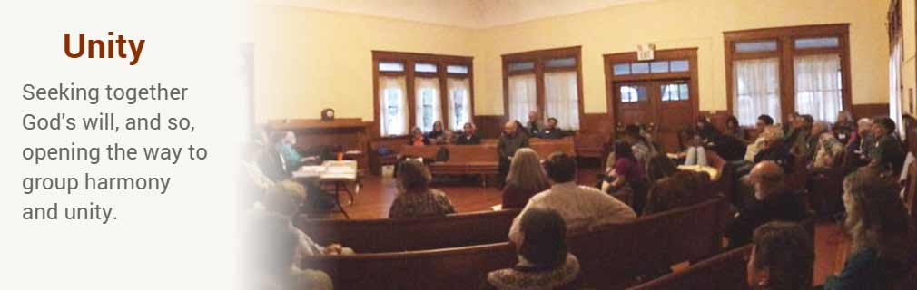

If you are led to give vocal ministry during the Meeting please keep your face covering on.

If you begin to feel unwell during Meeting please leave the room via the main door. The doorkeeper will follow you out to check how you are.

After Meeting for Worship
After the Meeting we will have conversation as a group in the meeting room (though of course you are free to leave at any time). We will share joys and concerns and ask for reflections on the Meeting or any brief notices. After this we will ask Friends to leave the Meeting House, going out through the fire exit unless they need to use the toilet. Please remember to take belongings, including any rubbish, with you.

Some happier words

